

FS SO-OD Printing COI in delivery documentation (form)

Functional Design Specification

Document Version Number: <Version Number>

Page 1 of 7

Table of Contents

Table of Contents 2
1 Business Functionality Overview 3
1.1 Functional Specification Type 3
1.2 Business Functionality 3
1.3 Security Considerations 3
1.4 Business Dependencies 3
1.5 Business Criticality 3
1.6 Assumptions 3
1.7 Overall Business Flow Diagram 3
2 Reports 4
2.1 Report Title 4
2.2 Report Description 4
2.3 Timing and Frequency 4
2.4 Selection Screen 4
2.5 Processing Logic 4
2.6 Layout 4
2.7 Error Handling Specifications 4
3 Interfaces 4
3.1 Type of Interface 4
3.2 Process / Data Flow Diagram 5
3.3 Sending and receiving systems involved (applications) 5
3.3.1 Sending system 5
3.3.1.1 Development and Test Servers 5
3.3.1.2 Production Server 5
3.3.1.3 Source Message structure: 5
<Filed names with Hierarchy> 5
3.3.2 Receiving system 5
3.3.2.1 Development and Test Servers 5
3.3.2.2 Production Server 6
3.3.2.3 : Target Message structure 6
<Filed names with Hierarchy> 6
3.4 Frequency and Volume 6
3.5 Logical Data Element Mapping 6
3.6 Trigger 6
3.7 Dependencies 6
3.8 Error Management and Data Recovery Specifications 6
4 Enhancements 6
4.1 Process Flow Diagram 6
4.2 Enhancement Specifications 6
4.2.1 Logic to trigger the batch determination 7
4.3 Error Handling Specifications 7
5 Forms 7
5.1 Layout 7
5.1.1 Output Types 7
5.1.2 Fields and Field Logic 7
6 Workflows 7
6.1 Process / Data Flow Diagram 7
6.2 Frequency and Volume 7
6.3 Roles and Responsibilities 7
6.4 Error Management and Data Recovery Specifications 7
7 Related Documents 8
8 Document History 8
9 Appendix 8

Business Functionality Overview

Functional Specification Type

FS Type | Applicable
Reports
Interfaces
Enhancements | X
Forms
Workflows

<Mark the respective object type>

Business Functionality

In order to guarantee the chain of identity there is a need to have the chain of identity field in all of the documents involved in the apheresis process.

“Sales Order and FDP Delivery

26. Create a delivery with required documentation. The COI information should be on
the delivery documents.”

Security Considerations

<Provide the security object details and any other security considerations>

Business Dependencies

<Provide details of any business dependency on any other object development or business process >

Business Criticality

<Define the business criticality of this functionality>

Assumptions

It is taken as an assumption that the sales orders for NL08 will always be created manually and through the t.code VA01.

Overall Business Flow Diagram

After saving the document and creating the delivery the system copies this batch automatically to the delivery via the standard control copy.

The batch in the delivery cannot be changed without changing first the batch in the sales order.

The delivery batch will automatically be transferred to the Transfer Order (WM) and this will be the batch that will be picked for the outbound process.

The main objective of this functional specification is to document where and how this number will be printed in the delivery form.

Reports

Report Title

Report Description

Timing and Frequency

Selection Screen

Display field name | Table | Field | Addition info

Processing Logic

Layout

The layout that will be changed is the one related with:
- Message type ZLD0
- Program ZVADDN01
- Form ZVDELNOTE

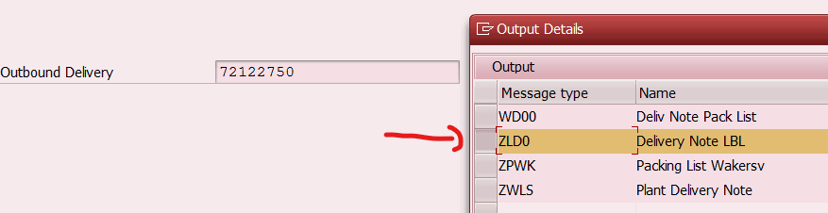

The COI will be printed at header level. As shown below
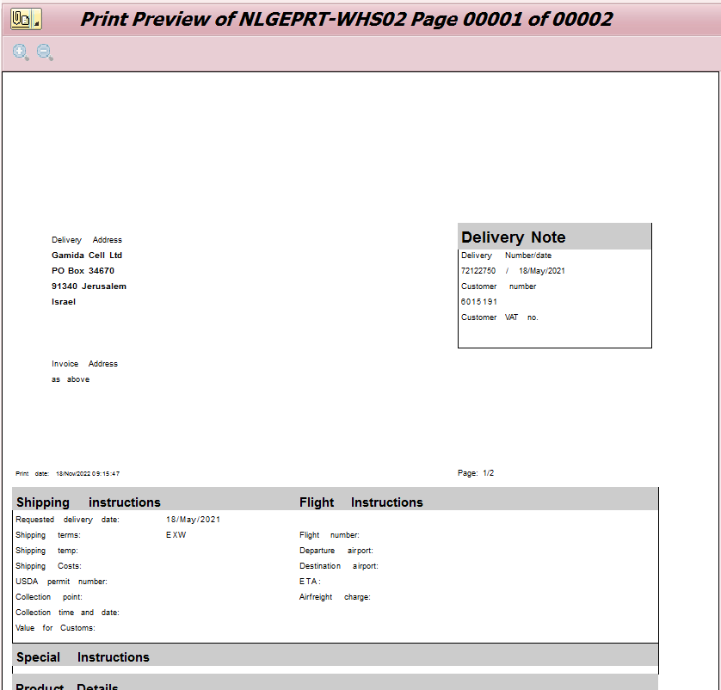
COI 100010001000

Error Handling Specifications

<Mention any specific error handling requirements, error logging etc>

Interfaces

Type of Interface

<Mention the type of interfaces such as ALE, IDOC, PROXY, XML, FTP etc.>

Process / Data Flow Diagram

<Flow diagram across systems and design details>

Sending and receiving systems involved (applications)

Sending system

Development and Test Servers

<Provide sender system details in development and test servers>
Source System | Eg : D10
Connecting protocol | Eg : IDOC , Proxy , RFC
Message format which will be transferred from source | Eg : IDOC xml
Security / Encryption requirement

Production Server

<Provide sender system details in production server>

Source System | Eg : P10
Connecting protocol | Eg : IDOC , Proxy , RFC
Message format which will be transferred from source | Eg : IDOC xml
Security / Encryption requirement

Source Message structure:

<Filed names with Hierarchy>

No. | Pos. | Field Name | Field Description | Field length | Comments

Receiving system

Development and Test Servers

<Provide receiver system details in development and test servers>

Target System | Eg : MES
Connecting protocol | Eg : Web services
Message format which will be transferred from source | Eg : flat file , EDI
Security / Encryption requirement

Production Server

<Provide receiver system details in production server>
Target System | Eg : MES
Connecting protocol | Eg : Web services
Message format which will be transferred from source | Eg : flat file , EDI
Security / Encryption requirement

: Target Message structure

<Filed names with Hierarchy>

No. | Pos. | Field Name | Field Description | Field length | Comments

Frequency and Volume

<Mention the frequency of run and the volume of data>

Logical Data Element Mapping

< Provide the mapping excel sheet which maps the source( Sap fields in case of outbound) and target fields( Sap fields in case of inbound)>

Trigger

<Describe what is the trigger of the interface. For instance : trigger program, batch job, transaction…>

Dependencies

<Mention the dependencies on the objects or business process>

Error Management and Data Recovery Specifications

< Workaround for error scenarios. Manual retrigger or automatic retrigger after data correction

Enhancements

Process Flow Diagram

Enhancement Specifications

Logic to trigger the batch determination

When printing the delivery, the system should check which COI number is related to the document that it is printing.

The logic should be, when calling the output print:

LIPS-VGBEL to find the sales order number.

Go to VBAK with LIPS-VGBEL = VBAK-VBELN to find VBAK-ZCOI.

The VBAK-ZCOI information is what should be shown in the delivery header.

Error Handling Specifications

<Various potential errors and handling of errors>

Forms

Layout

Program ZVADDN01
Form ZVDELNOTE

Output Types

ZLD0 - Delivery Note LBL

Fields and Field Logic

VBAK-ZCOI

Workflows

Process / Data Flow Diagram

<Define the different steps and actions in detail – starting from triggering of workflow to workflow completion. Also mention the agent determination logic here>

Frequency and Volume

<Mention the frequency of run and the volume of transaction>

Roles and Responsibilities

<Define the different agents for each action and their responsibilities>

Error Management and Data Recovery Specifications

<Workaround in case of workflow error>

Related Documents
<Mention the related document names and respective path>

Dcoument Name | Document Path
<TS doc> | Path

Document History

Ver # | Date | Author | Brief Description of change
1.0 | 31-Oct-2022 | Paulo Pimenta | COI in delivery

Appendix

<Any supporting document to be added as appendix>

